Thomas Crow

CS334

Lab #2

2/18/2022

Exercise 2.1

*<!DOCTYPE html>*

*<title>A Very Small Document</title>*

*<p>This is a simple document with not much content</p>*

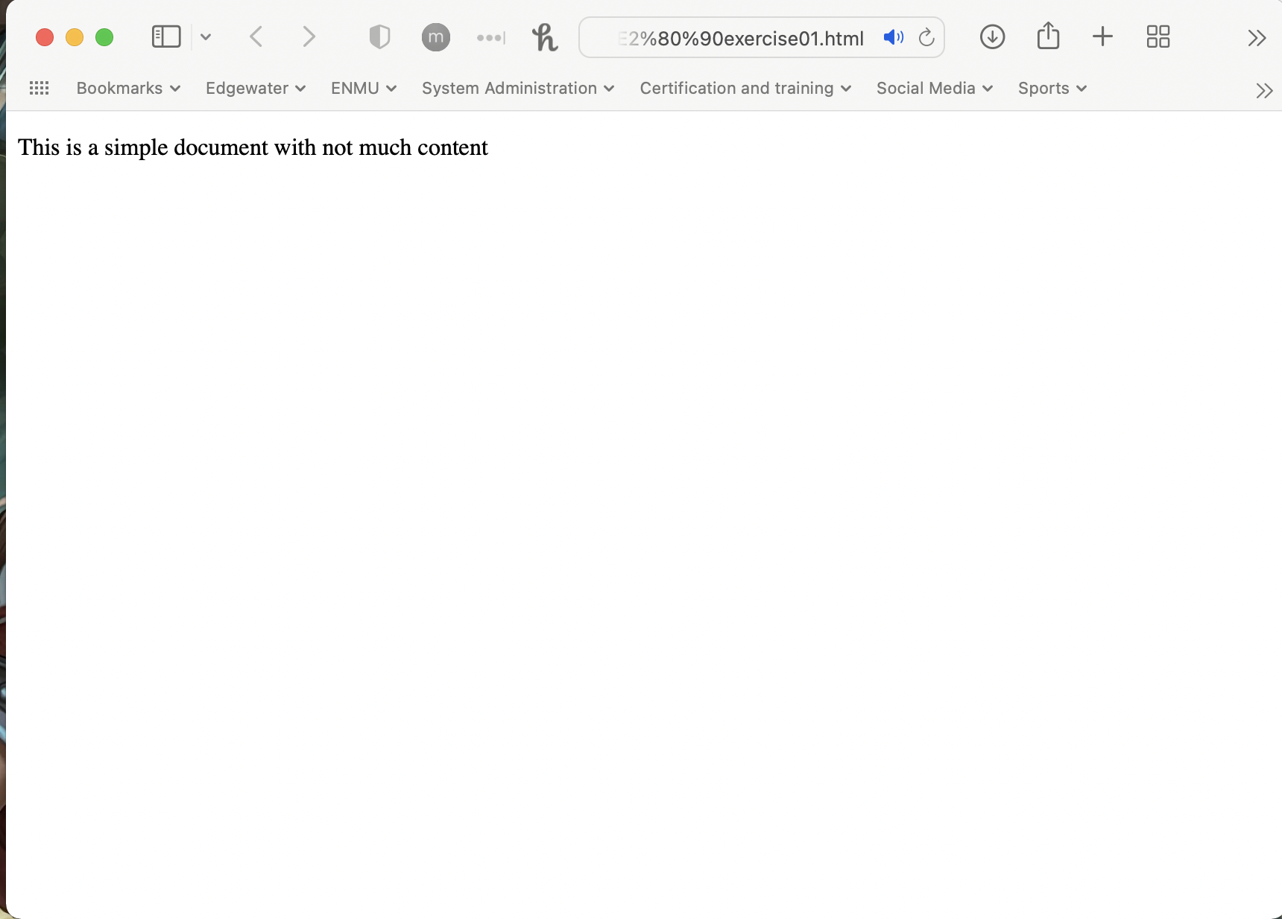

*Switch back to your text editor. Position the cursor before “This is a simple” and then*

*press Enter three times. Position cursor after the word “much”. Press space five times.  
Save the changes and then switch back to browser. Refresh the page.*

*Notice that the browser ignores extra spaces and paragraph returns*

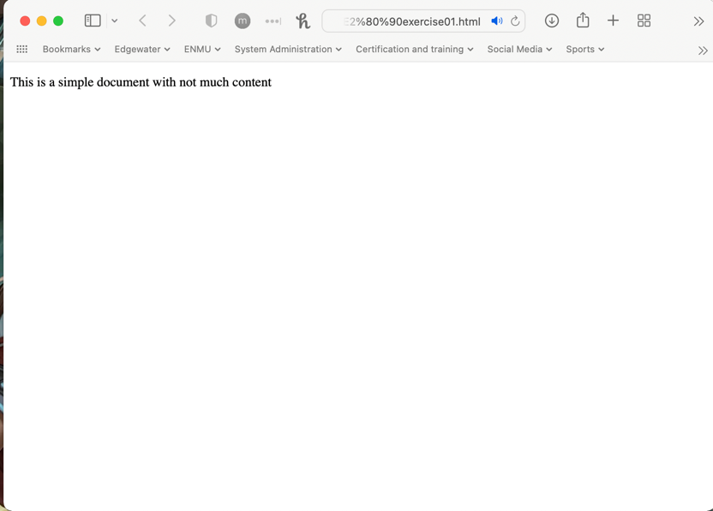

Exercise 2.2

*Create a new HTML document with the following content:*

*<!DOCTYPE html>*

*<html>*

*<head lang="en">*

*<meta charset="utf‐8">*

*<title>Share Your Travels ‐‐ New York ‐ Central Park</title>*

*</head>*

*<body>*

*<h1>Share Your Travels</h1>*

*<h2>New York ‐ Central Park</h2>*

*<h3>Description</h3>*

*<p>Photo by Randy Connolly</p>*

*<p>This photo of Conservatory Pond in Central Park New York City was*

*taken on October 22, 2011 with a Canon EOS 30D camera.*

*</p>*

*<h3>Reviews</h3>*

*<div>*

*<p>By Ricardo on September 15, 2012</p>*

*<p>Easy on the HDR buddy.</p>*

*</div>*

*<hr/>*

*</body>*

*</html>*

*Notice that this document has additional structure tags (<head>, <body>, <html>) that*

*were required in XHTML but are now optional in HTML5.*

*Save your file as lab02‐exercise02.html and test file in browser. The result should*

*look similar to that shown in Figure 2.1.*

*Figure 2.1*

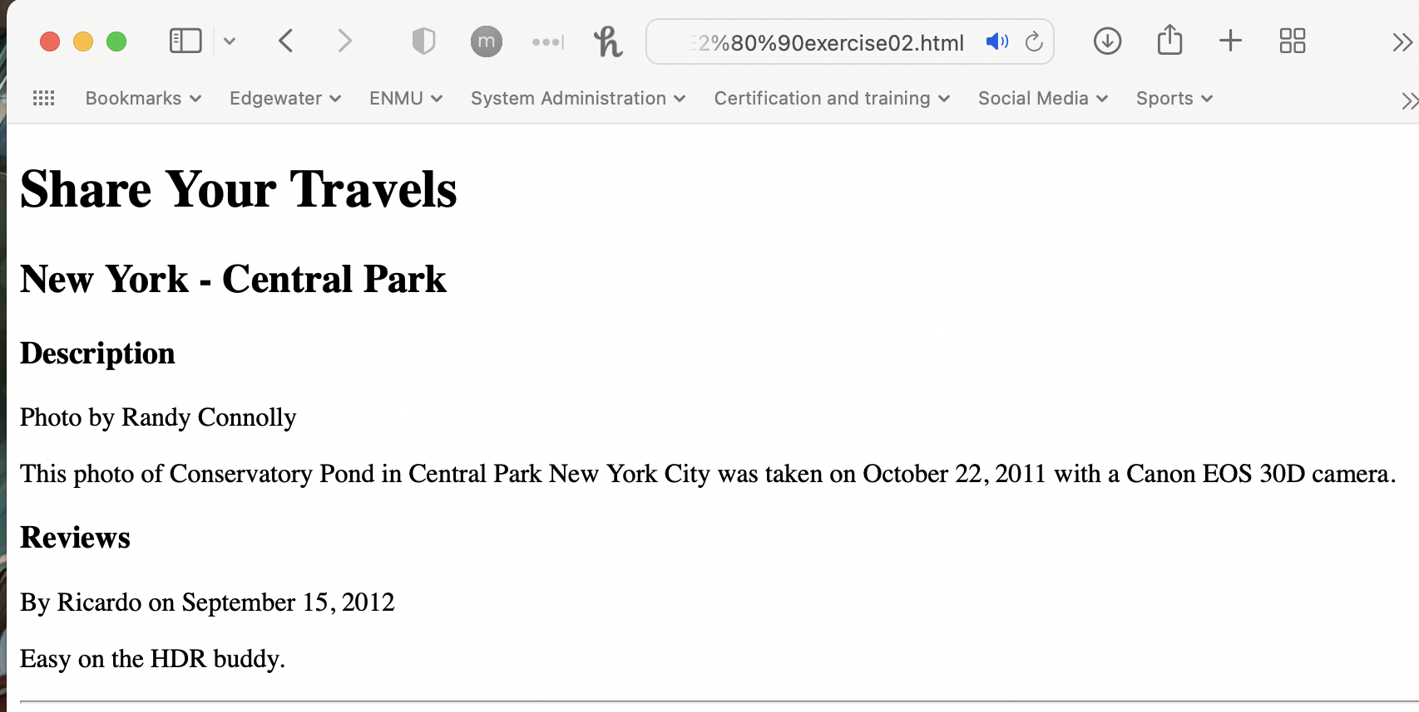

Exercise 2.3  
*Open lab02‐exercise03.html (which has the same content as the last exercise).  
Before the text “Conservatory” (in the second paragraph tag), add the tag <randy>.*

*Save and then test in browser. After testing, remove the <randy> tag.*

*Sadly there is no <randy> tag in HTML. Your browser will simply ignore any tag it does*

*not recognize.*

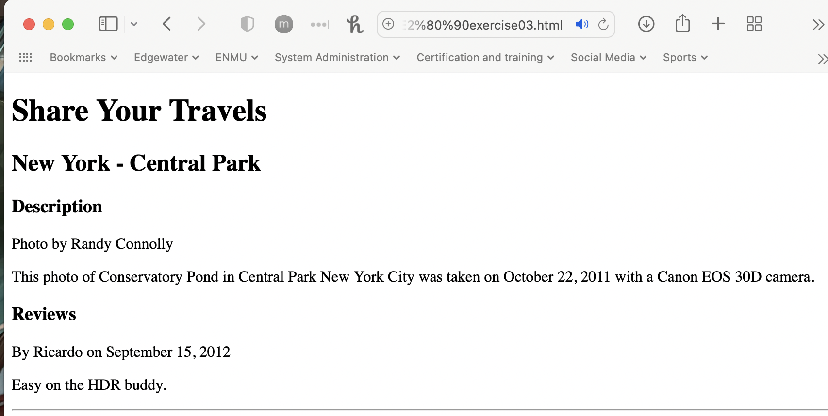  
*Remove the trailing </h1> end tag, save and then test.*

*Since the <h1> tag is never closed, the browser assumes that the content after it should*

*continue being displayed as a first-level heading.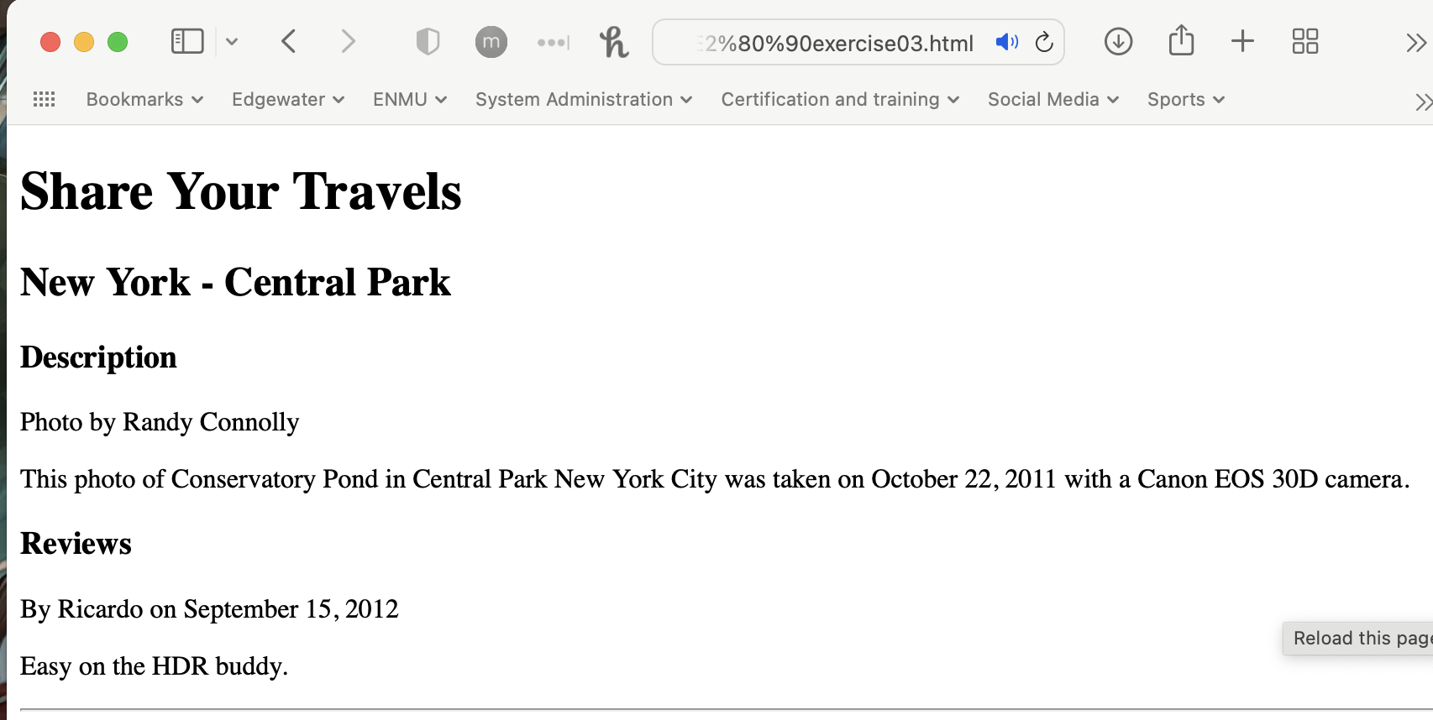 Put back the trailing </h1> end tag (i.e., after “Share Your Travels”).*

*Change the <h1> tag to <H1>, save and then test.*

*Notice that HTML5 is case insensitive.*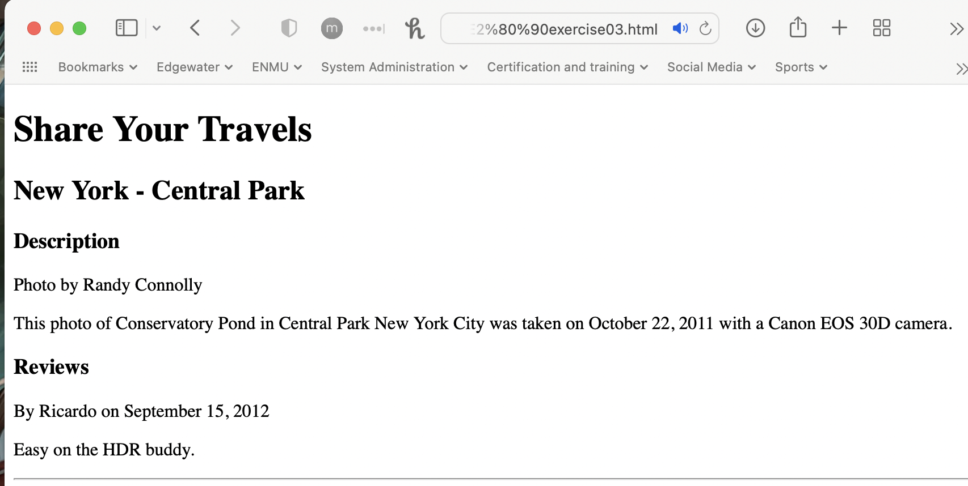

Exercise 2.4  
*Add the following bolded text:*

*<p>This photo of Conservatory Pond in*

*<a href="http://www.centralpark.com/">Central Park</a> in New York City was*

*taken on October 22, 2011 with a Canon EOS 30D camera.*

*</p>*

*This will create an external link.  
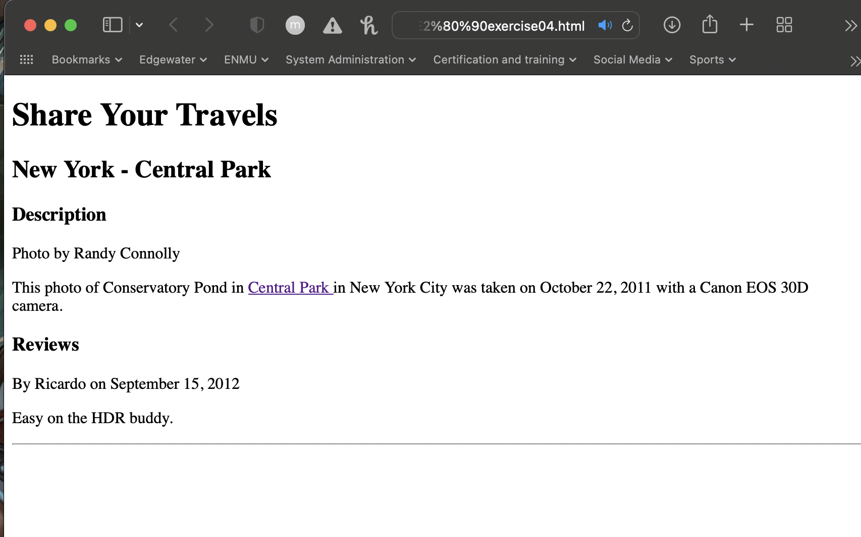*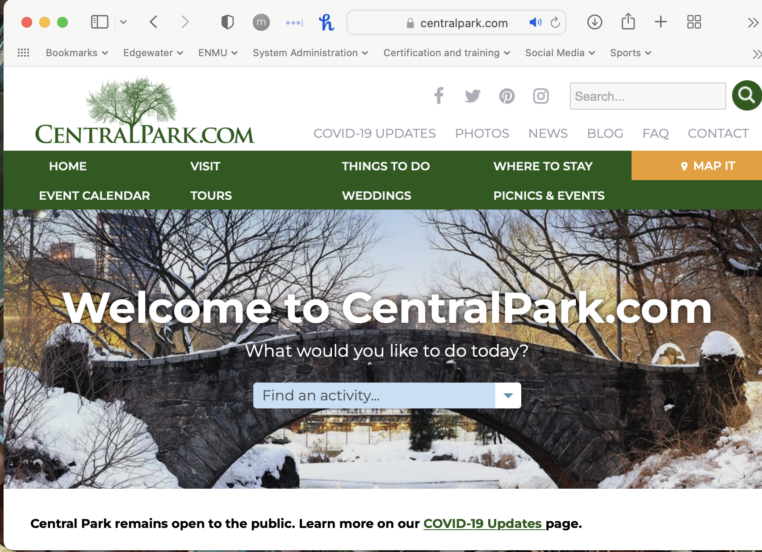

*Modify the document by adding the following link and test.*

*<p>This photo of Conservatory Pond in*

*<a href="http://www.centralpark.com/">Central Park</a> in*

*<a href="newyork.html">New York City</a> was*

*taken on October 22, 2011 with a Canon EOS 30D camera.*

*This will create a relative link (i.e., a link to another page in the same web site).  
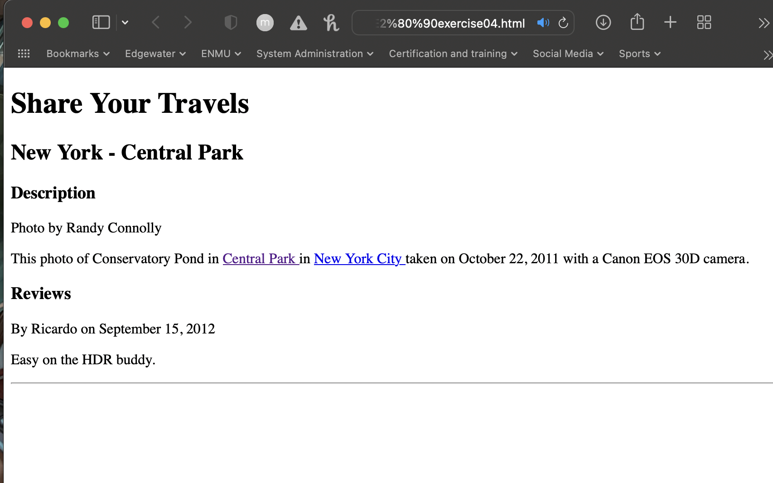  
(The link <a href="newyork.html"> tries to reference a file in the directory of lab02‐exercise04.html, which does not exist in the lab02.zip file in Canvas)*

*Exercise 2-5*

*Add the following tag and then test:*

*<img src="images/central‐park.jpg" alt="Central Park" />*

*<h3>Reviews</h3>*

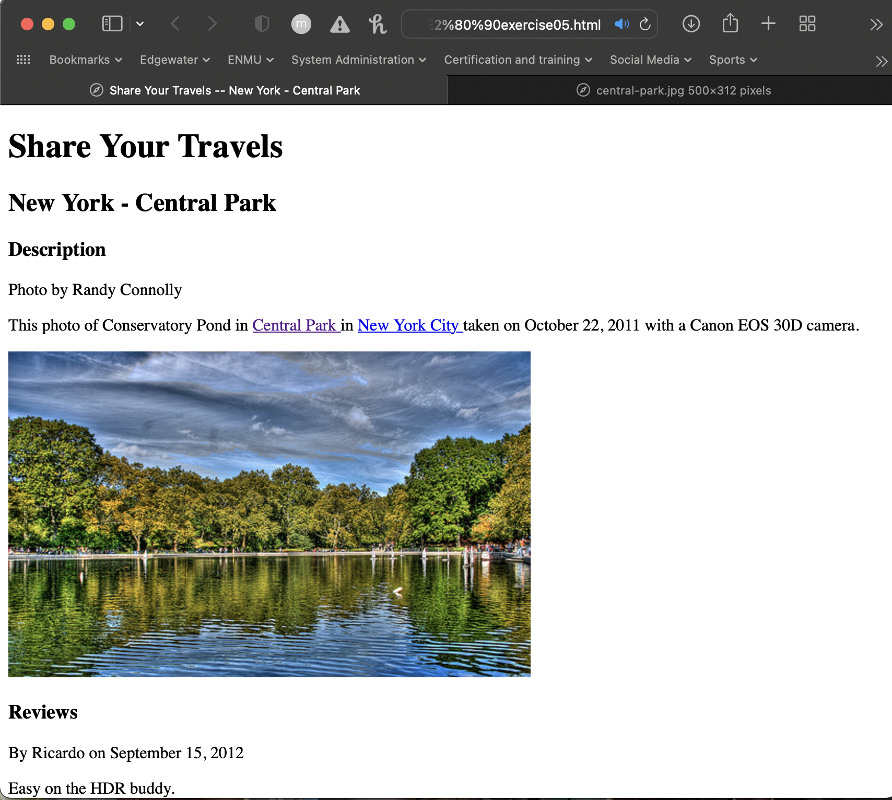

I had to use the path <img src="file:///Users/tbcrow/git-repos/ENMU/CS334/Labs/Lab%232/images/central-park.jpg" alt="Central Park" /> to get the image to display on my Mac.

*Modify the image tag as follows and test (be sure to move your mouse over the image).*

*<img src="images/central‐park.jpg" alt="Central Park"*

*title="Central Park" />*

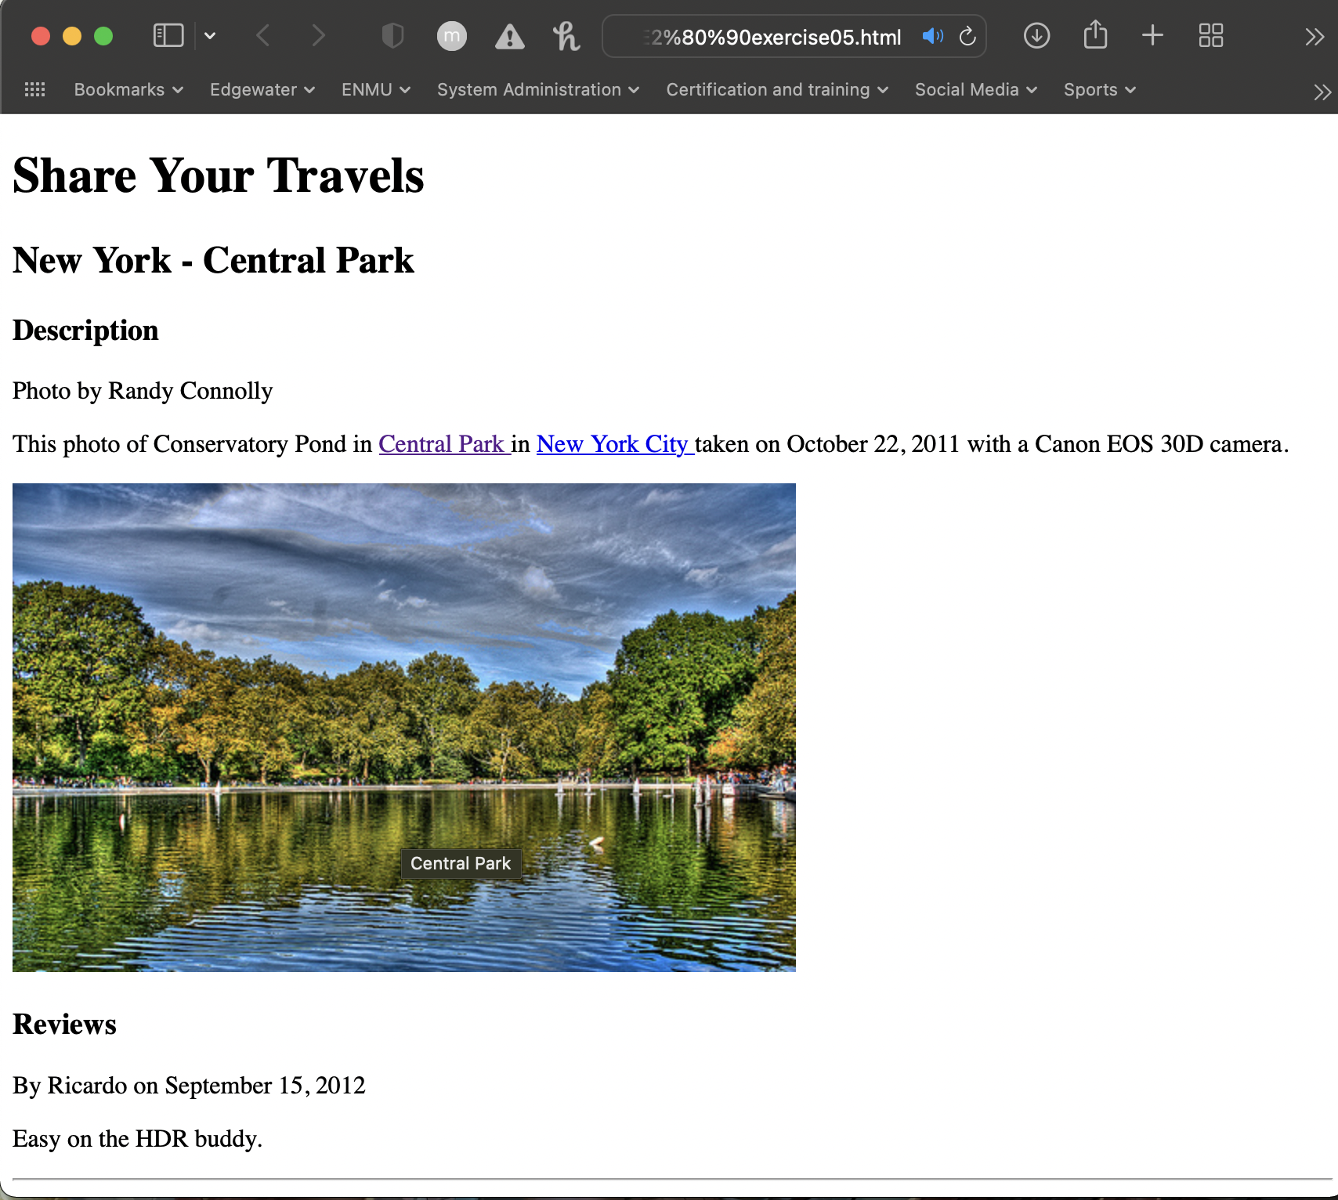

*Change the src attribute to the following (i.e., add a slash before the folder name) and*

*test.*

*<img src="/images/central‐park.jpg" alt="Central Park"*

*title="Central Park" />*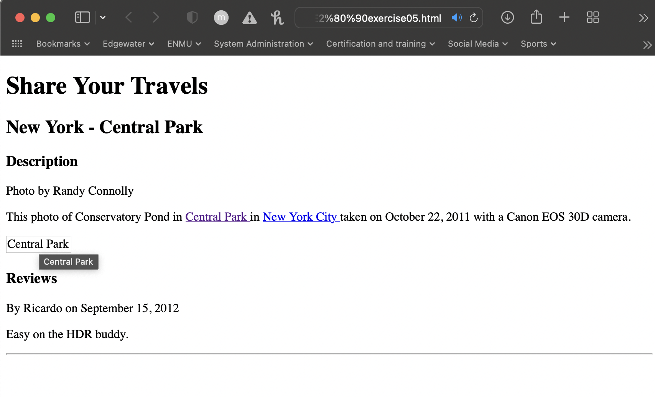

*Add the following and then test:*

*<a href="images/large‐central‐park.jpg">*

*<img src="images/central‐park.jpg" alt="Central Park" />*

*</a>*

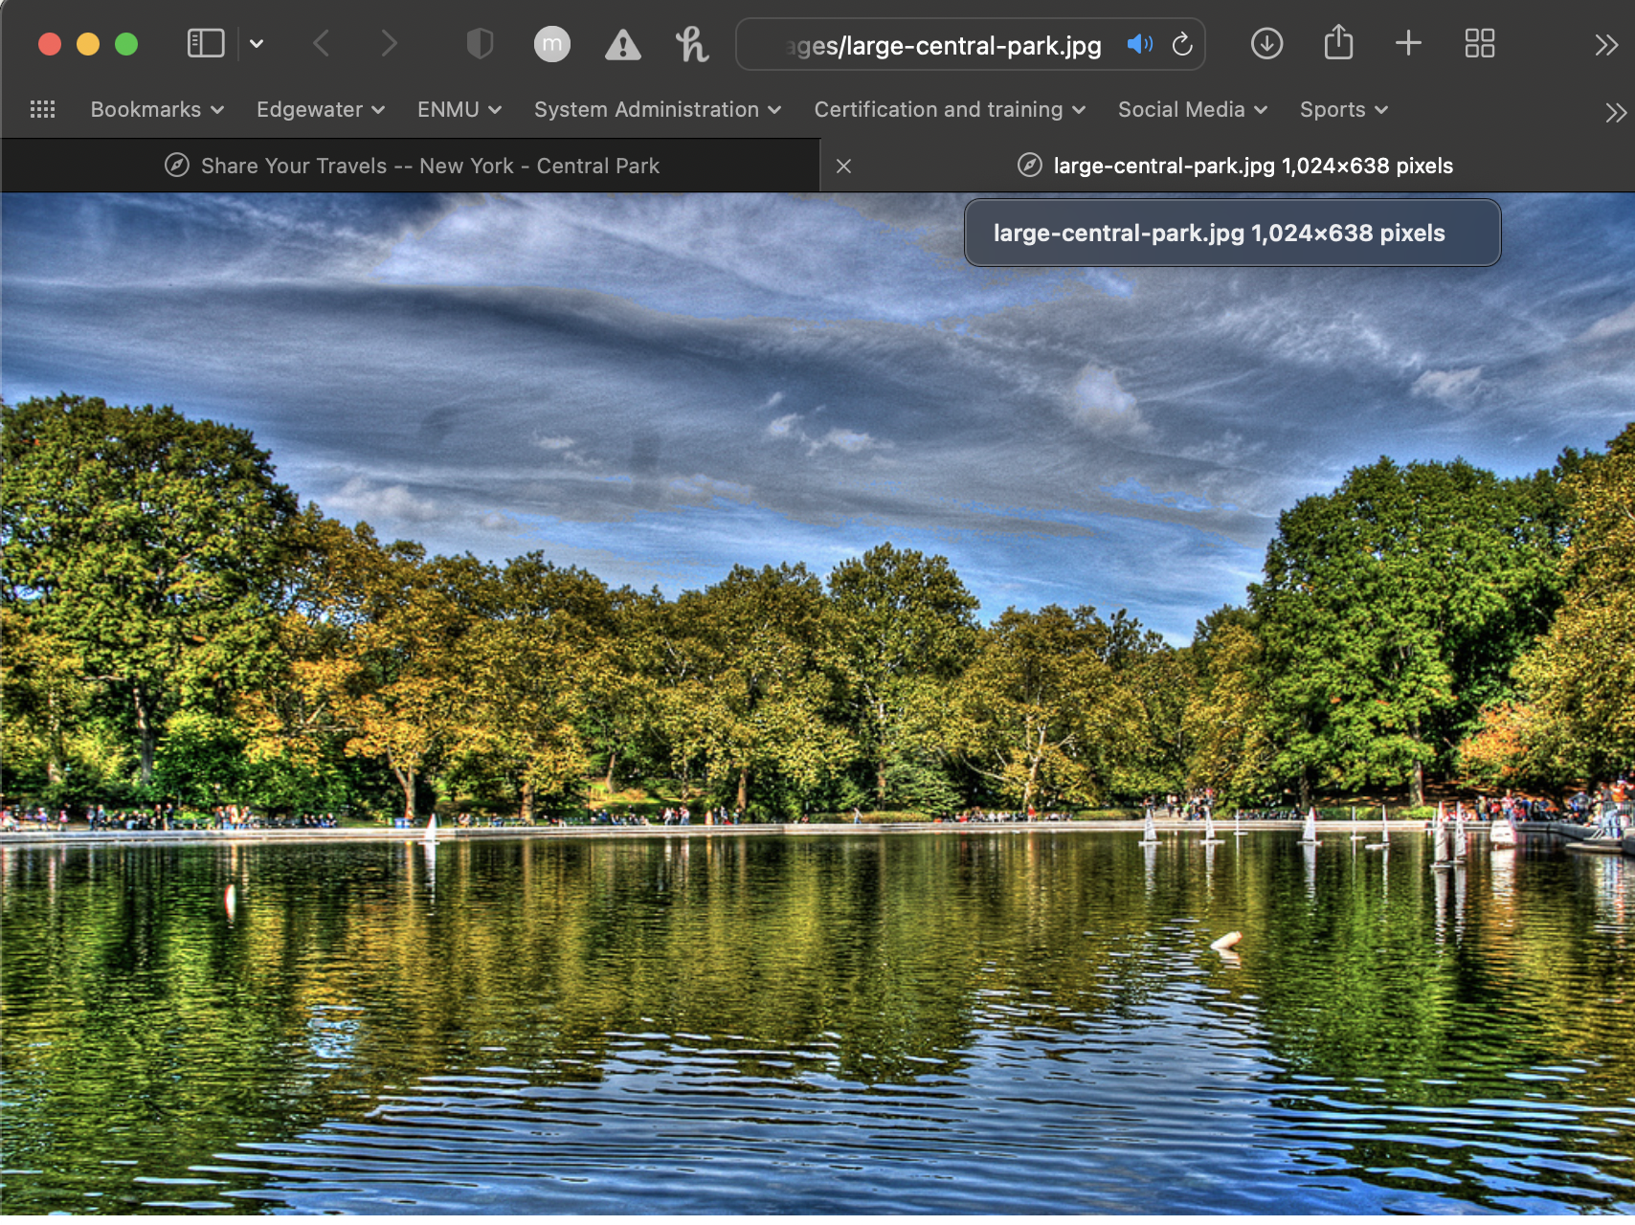  
*Add the following after the Central Park image:*

*<p>Share:*

*<img src="images/social/email_16.png" alt="Email this to someone" />*

*<img src="images/social/rss_16.png" alt="Syndicated content" />*

*<img src="images/social/twitter_16.png" alt="Share this on Twitter" />*

*</p>*  
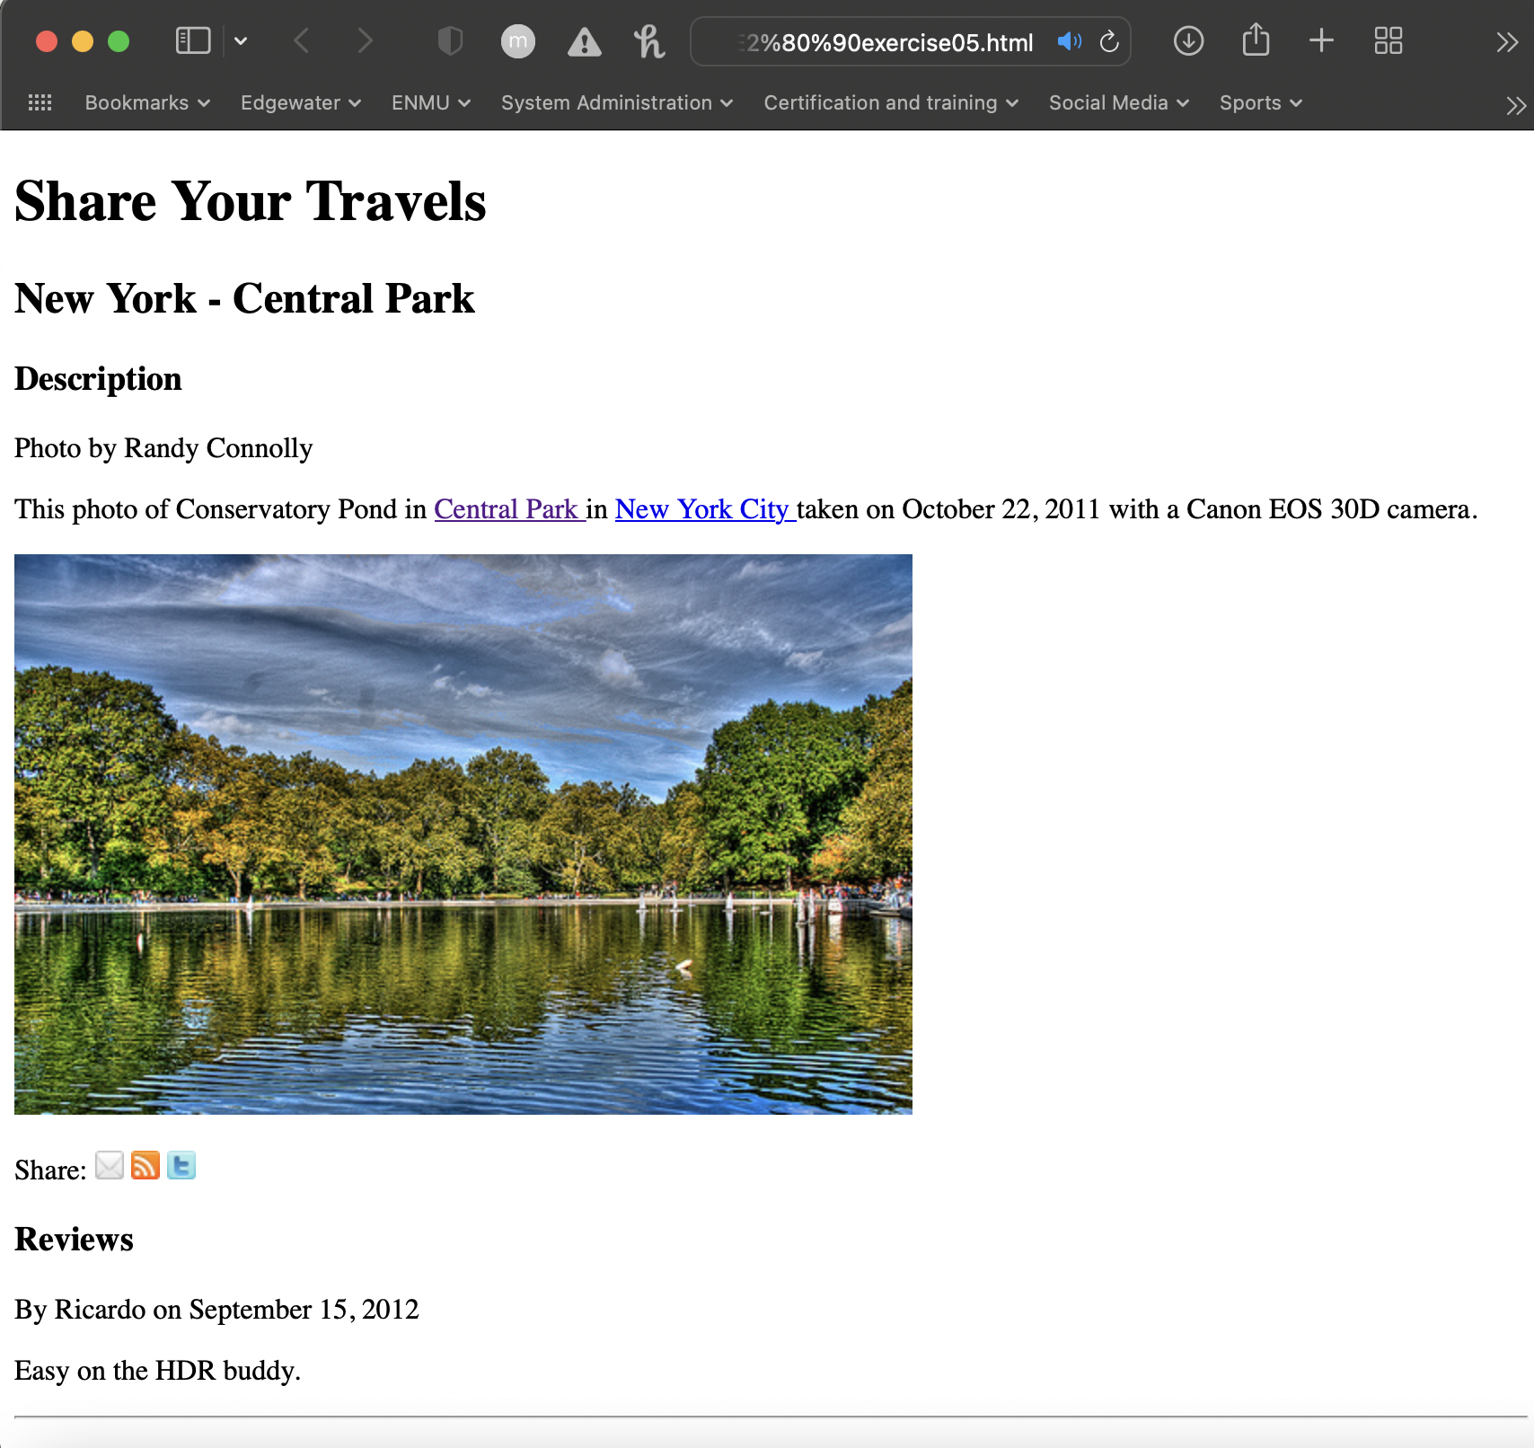

*Remove the returns between each <img> tag, as shown below, and then test.*

*<p>Share:*

*<img src="images/social/email_16.png" alt="Email this to someone" /><img*

*src="images/social/rss_16.png" alt="Syndicated content" /><img src=*

*"images/social/twitter_16.png" alt="Share this on Twitter" />*

*</p>*  
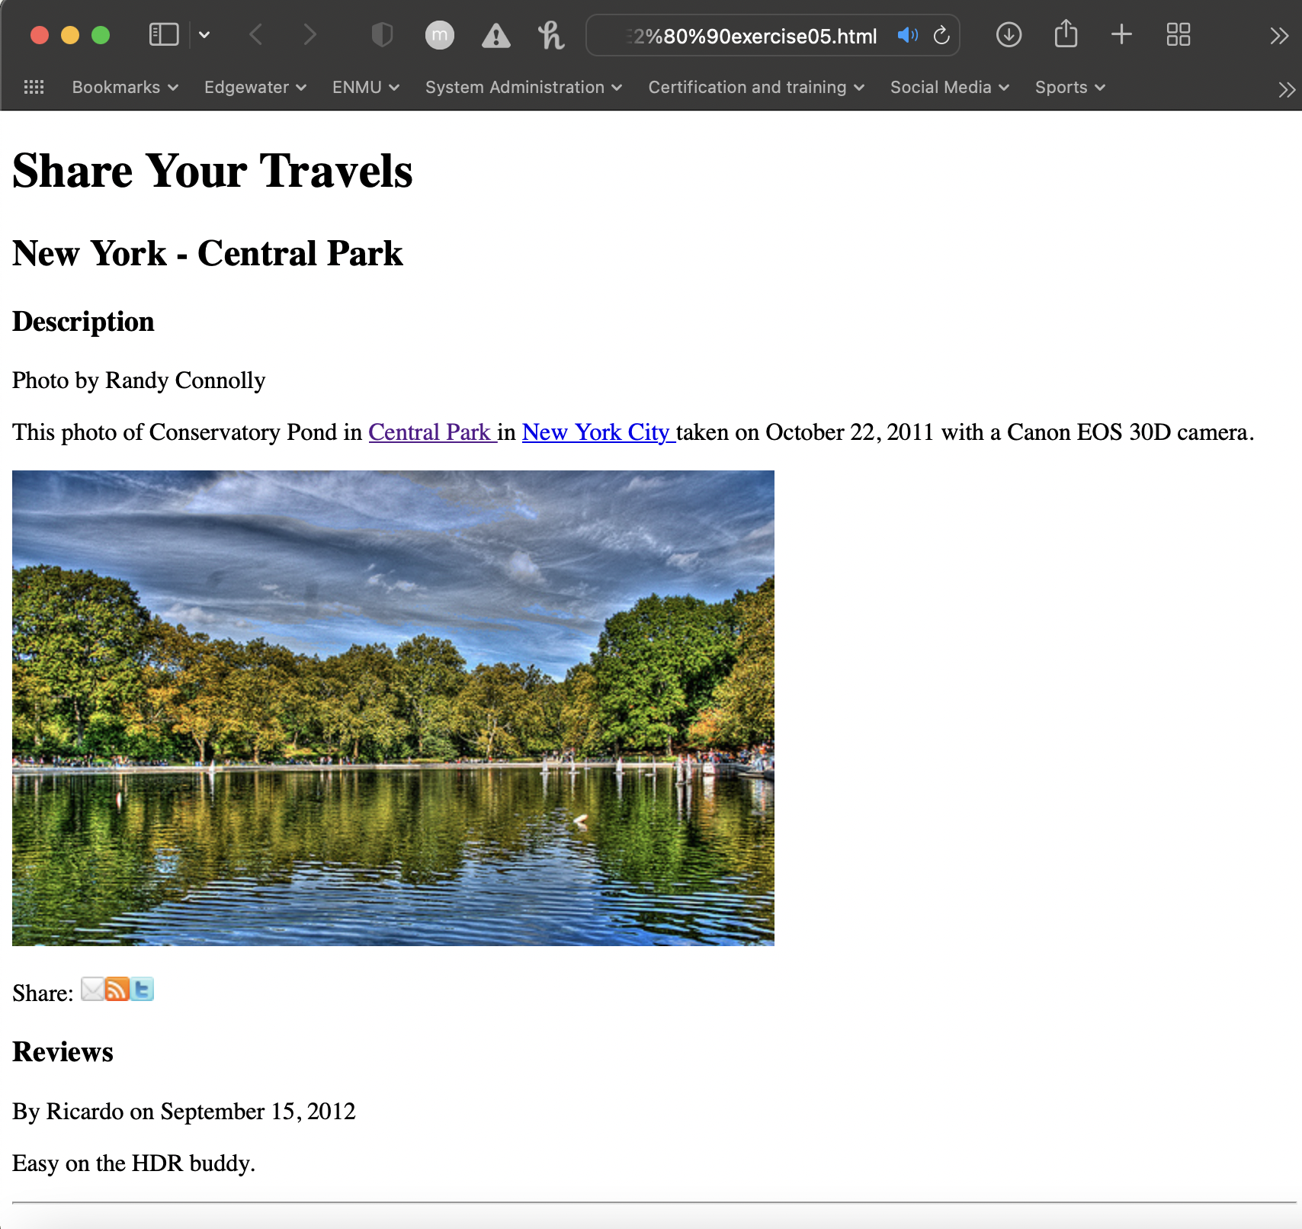

*Modify the following and test.*

*<p>Share: <br/>*

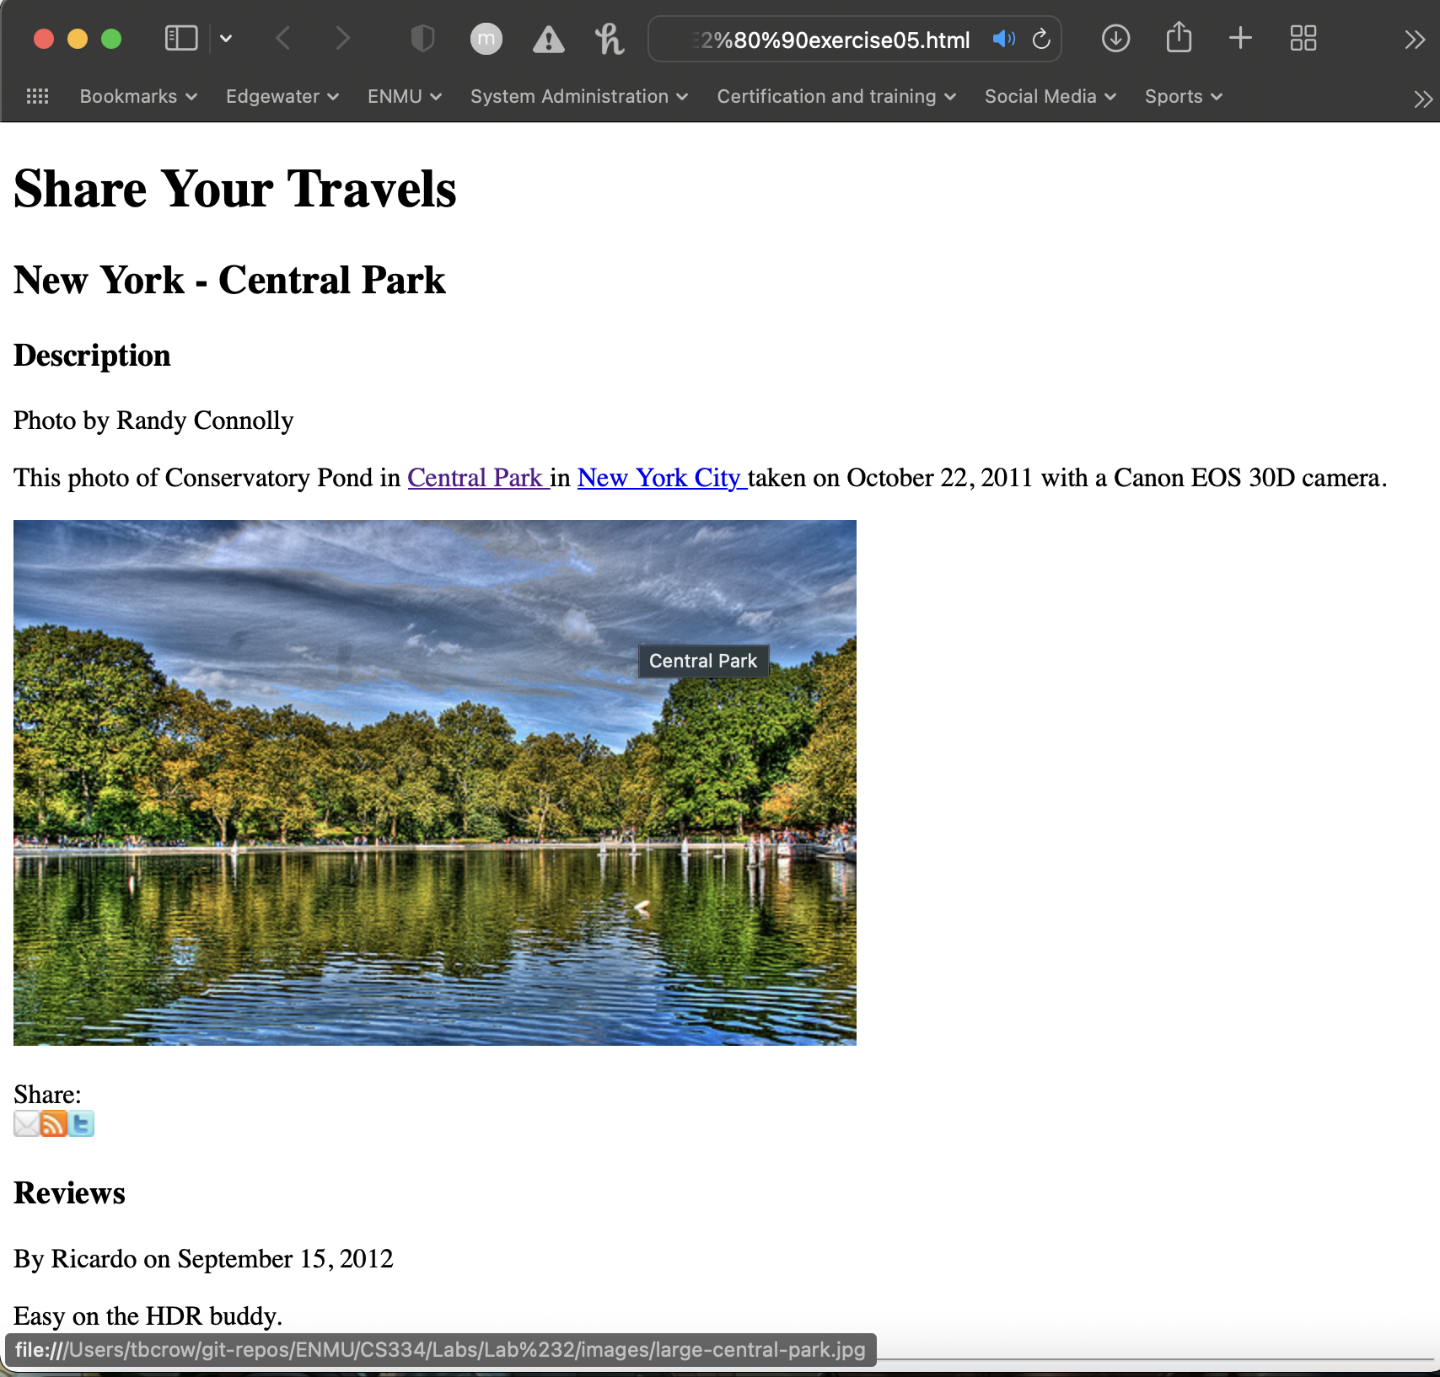

Exercise 2-6  
*Open lab02‐exercise04.html and add the following bolded text:*

*<body>*

*<h1>Share Your Travels</h1>*

*<h2>New York ‐ Central Park</h2>*

*<ul>*

*<li>Description</li>*

*<li>Reviews</li>*

*</ul>*

*<h3>Description</h3>*

